**Server Archive Process in Azure**

**Step1: Create Image from VM**

**Image Type:**

1. **Generalized**

We need to run Sysprep on Windows & waagent -deprovision in Linux, it will be deleted computer name and user profiles

1. **Specialized**

We can capture the image without doing Sysprep, it will have same computer name and user profiles

**Option1:**

**Capturing Image:**

Select VM which we want capture Image and select capture button

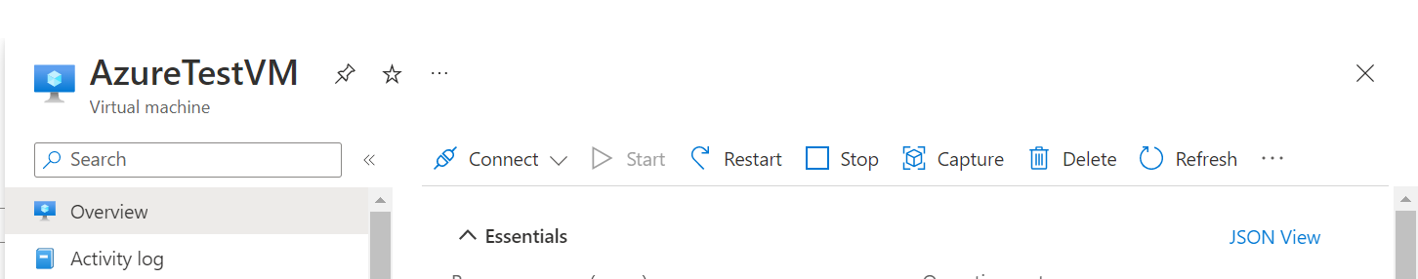

**Option2:**

Going to disk -->settings--> export disk--> export VHD disk --> upload to storage account

* Go to disk settings and export disk to save .vhd and store the .vhd file into storage accounts.

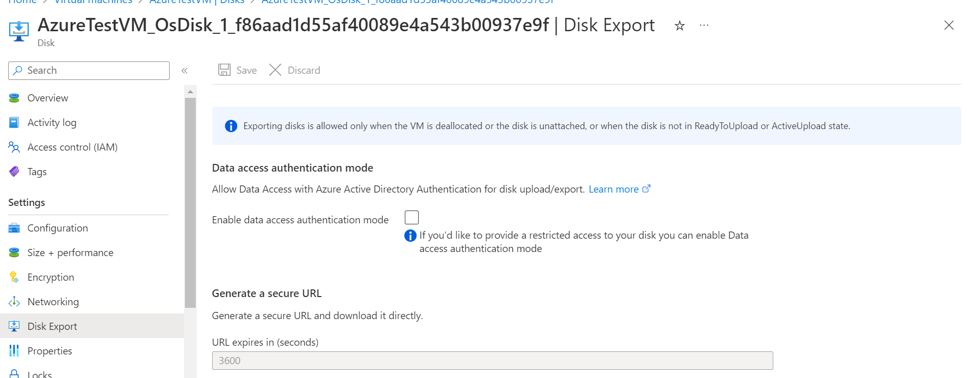

**Step2: STORAGE ACCOUNT**

**Archieve tier--> min 180 days**

Storing data is less cost and retrieve data will costly

**cool--> min 30 days**

Storing data is less cost and retrieve data will costly

**Hot--> frequently moving data's**

Storing data is costly and retrieving is less cost

**Storing Images:**

images stored in image gallery for best option.

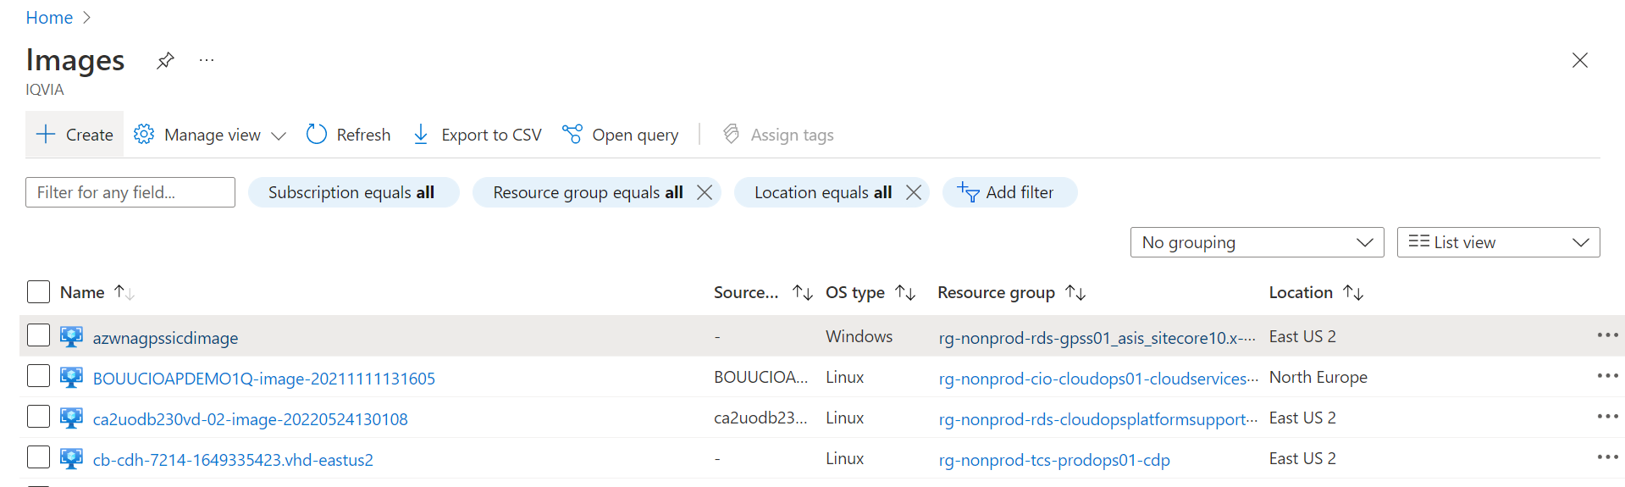

* Disks to store in storage account as VHD using disk export option and then upload to the storage account to container blob storage
* Cool tier was better option for storing (store is less & retreive is high)